Project Design Phase-II
Data Flow Diagram & User Stories

Date | 31 January 2025
Team ID
Project Name
Maximum Marks | 4 Marks

Data Flow Diagrams:
A Data Flow Diagram (DFD) is a traditional visual representation of the information flows within a system. A neat and clear DFD can depict the right amount of the system requirement graphically. It shows how data enters and leaves the system, what changes the information, and where data is stored.

Example: (Simplified)



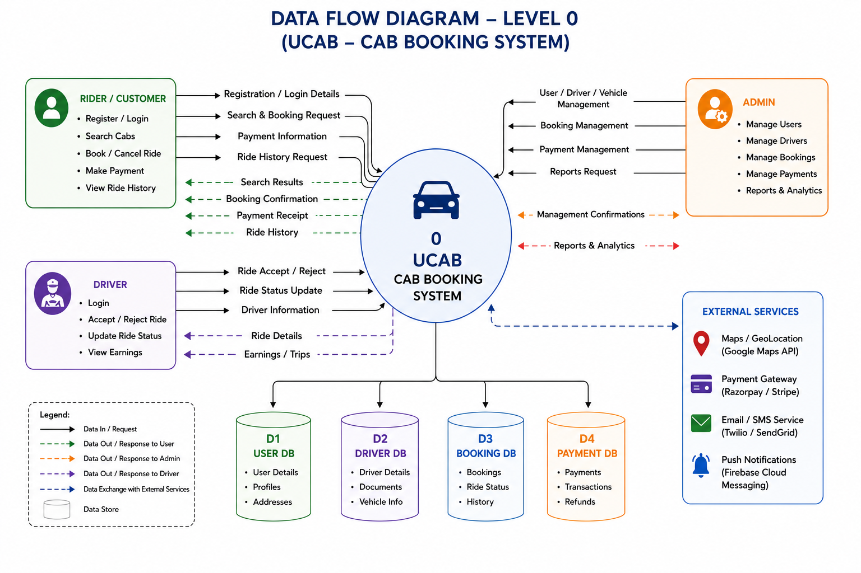
User Stories
Use the below template to list all the user stories for the product.
User Type | Functional Requirement (Epic) | User Story No | User Story / Task | Acceptance Criteria | Priority | Release
Customer (Web User) | Registration | USN-1 | As a user, I can register using my email and password. | User account is created successfully. | High | Sprint-1
Customer (Web User) | Login | USN-2 | As a user, I can log in securely. | User is redirected to the dashboard. | High | Sprint-1
Customer (Web User) | Cab Booking | USN-3 | As a user, I can select a cab type before booking. | Selected cab is displayed correctly. | High | Sprint-2
Customer (Web User) | Fare Estimation | USN-4 | As a user, I can view the estimated fare before confirming the booking. | Fare is calculated correctly. | High | Sprint-2
Customer (Web User) | Ride Booking | USN-5 | As a user, I can book a cab successfully. | Booking confirmation is displayed. | High | Sprint-2
Customer (Web User) | Scheduled Booking | USN-6 | As a user, I can schedule a ride for a future date and time. | Scheduled booking is saved successfully. | Medium | Sprint-3
Customer (Web User) | Ride Management | USN-7 | As a user, I can cancel or reschedule my booking. | Booking status is updated successfully. | Medium | Sprint-3
Customer (Web User) | Ride History | USN-8 | As a user, I can view ride history and download receipts. | Previous rides and receipts are available. | Medium | Sprint-4
Driver | Ride Management | USN-9 | As a driver, I can accept or reject ride requests. | Ride status is updated correctly. | High | Sprint-3
Driver | Trip Status | USN-10 | As a driver, I can update ride status (Started/Completed). | Users receive updated ride status. | High | Sprint-3
Administrator | Dashboard | USN-11 | As an admin, I can manage users, drivers, bookings, and payments. | Admin dashboard displays all management options. | High | Sprint-4

